
Service Offering

- Align Business Operations to a fast paced Market
- Studying dynamic customer behaviour and changing requirements
- Building applications that can cope with heterogeneous platforms
- Internationalization and Localization requirements
- Systems with a long life, maintenance costs may be several times development costs
- Additional overheads when changes occur in application or product environment
- improving time-to-market capabilities

Key Challenges and Issues
Software is a key element for enterprises enabling specialized problem-solving, information management & storage, information processing & analysis, process automation, and core business operations.

Application and Product Engineering
Baryons Software Solutions
zzzzzzzzzz
With years of systems integration and technology services experience, we offer a comprehensive portfolio of services. Baryons Service offering rests on the three cardinals – People, Process and Technology. Baryons keep on investing in these pillars to achieve continuous improvement in IT Services delivery.
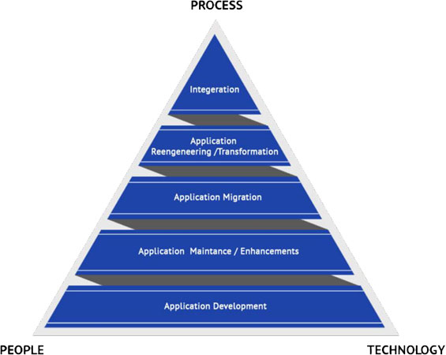

- Portals & E-Commerce

- Enterprise Content Management

- Enterprise Collaboration

- Enterprise Application Integration & Automation

- Application Modernization

- Media Platforms

- Reusable Frameworks enable Shorter Time to Market Robust and Secure platforms
- Flexibility, Performance & Scalability
- Significant Reduction of Maintenance Costs
- Flexible Engagement Models
- Strong Project Management ensures Consistent Adherence to Costs & Schedule
- Continuous Change Management through SCRUM Risk Mitigation and Impact Management

Benefits
phase.
Maintenance

- Adaptive, Perfective, Corrective & Preventive
- System Discovery, Base-lining & Transitioning
- Effective Communication, Governance & Knowledge Management
- Managed Services Model for Production & Engineering Support
Migration

- Technology Platforms Upgrade
- Risks Mitigation & Managing Outages
- Modernization through Cloud, Web & Mobile Enablement
Reengineering
- Feasibility Assessment
- Technology Selection
- Architecture Re-engineering
- Integration with Legacy Applications
Development
- Rapid Development using AGILE methodologies
- End-to-End Solution Implementation
- Fixed Price Model & Milestone Based Delivery
- Managed Services Model - ODC & Extended Teams
- Post-Deployment Maintenance & Support
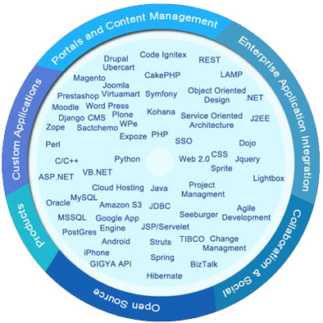
E-Learning System
- Identify Integration Strategy for managed growth
- Design & Implement Web Service interfaces
- Design & Implement Data Interchange interfaces for database level integrations
- Integrate with 3rd Party API & Web Services
- Enterprise Authentication for all business applications
Performing software applications require constant innovation and must adapt to technology landscape evolution while working within cost and time constraints.
www.baryonssoftsolutions.com
Phone : +91 80 41759582
Email : business@baryonssoftsolutions.com
Skype : baryonssoft

