
Key Challenges and Issues
Customers throughout the world face a big problem of availability of accurate data at the right time to take crucial decisions in the organization, irrespective of its size.

Data Management Services
Baryons Software Solutions
zzzzzzzzzz
- Clean and reliable data
- ETL of data into target system in real time
- Need for 24/7 proactive monitoring
- High Cost of Ownership – High Skill DBAs
- Database Performance Issues – Continuous tuning
- Data recovery/availability
- Handling unplanned outages
- Database Migration or Version Upgrade
Overall System

phase.
We have years of systems integration and technology services experience to manage risks and provide solutions that meet the needs of the enterprise. We offer a comprehensive portfolio of services based on our experience.

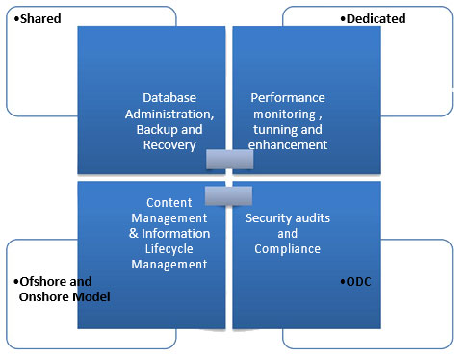

- Optimized performance of business critical databases 24X7
- Fast, cost-effective, DBA-backed migration service for error-free migration
- Multi skilled pool to minimise individual dependency
- Improve utilization of your IT infrastructure with our performance monitoring and tuning service
- Efficient monitoring and maintenance of business-critical databases
- Quicker response time and problem rectification
- End user delight by meeting all the different user expectations
- Higher ROI due to the use of Baryons services compared to using internal DBAs
Benefits to our customer
- Remote and In-Situ database administration
- Data archival and recovery solutions
- DBMS Performance tuning
- Database platform migration and version upgrade
- RDBMS or MySQL database implementation
Our Database Management
Services include:
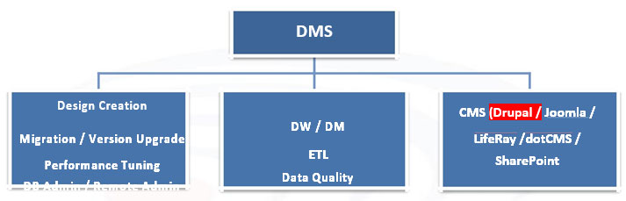
Our consultants can work with your team to define a data ETL strategy for data upload onto your data warehouse or data mart platforms.
Our Data Quality services include data cleansing, data validation, data clustering, and ETL services. Our consultants can enable you define a data quality management plan and systems for its implementation
www.baryonssoftsolutions.com
Phone : +91 80 41759582
Email : business@baryonssoftsolutions.com
Skype : baryonssoft

